Tutorial: Knitted Blue Whale
This guide simplifies the whale shown in the reference photos. It is written for a beginner-friendly project: make a soft oval body, add a white belly, sew on fins and tail pieces, then finish with embroidered face details.

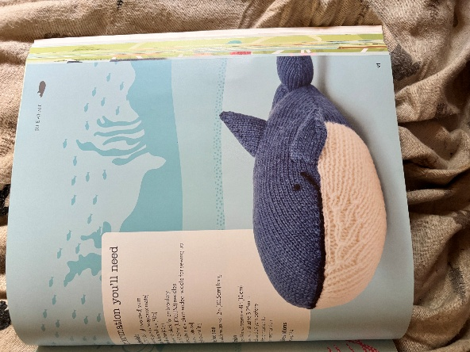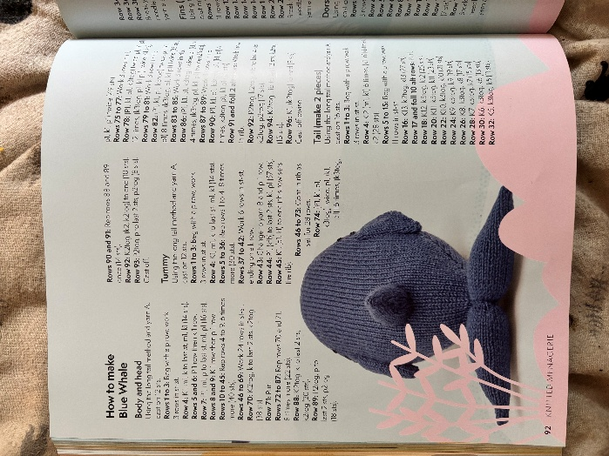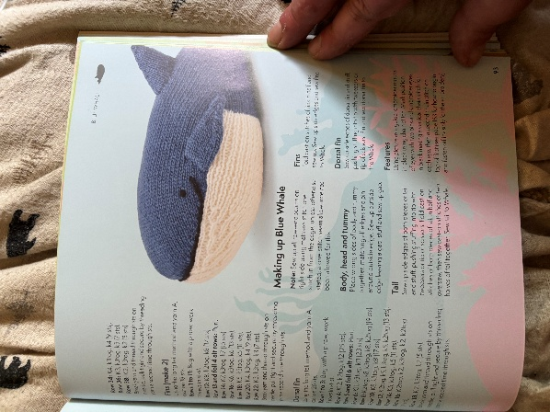

Super Simple Step-by-Step Guide
1. **Knit the blue body.** Make one large rounded oval or tube shape. This is the main whale body.
2. **Sew the body seam.** Sew around most of the body, but leave one small opening for stuffing.
3. **Knit the white belly.** Make one cream or white oval panel that fits on the lower front of the whale.
4. **Sew on the belly.** Pin the white piece to the bottom/front of the body, then sew around the edge.
5. **Make two side fins.** Knit two small blue teardrop shapes.
6. **Attach the side fins.** Sew one fin on each side of the whale, angled slightly downward.
7. **Make the top fin.** Knit one small blue triangle for the dorsal fin.
8. **Attach the top fin.** Sew it to the top center of the whale.
9. **Make the tail.** Knit two flat blue tail pieces and sew them together at the middle.
10. **Attach the tail.** Sew the tail to the narrow back end of the whale.
11. **Stuff the whale.** Add stuffing a little at a time until the body is soft and rounded.
12. **Close the opening.** Sew the stuffing gap shut with small stitches.
13. **Add the face.** Use black thread to make one small eye and a curved mouth line.
14. **Shape and finish.** Gently press the whale into shape and hide any loose yarn ends.

Simple order to remember: **body, belly, fins, tail, stuffing, face.**

Supplies

| Item | Use |
|---|---|
| Blue yarn | Main body, fins, dorsal fin, and tail |
| Cream or white yarn | Belly panel |
| Small amount of black yarn or embroidery thread | Eye and mouth |
| Knitting needles | Use the size recommended for your yarn |
| Yarn needle | Sewing pieces together |
| Stuffing | Filling the whale |
| Pins or stitch markers | Holding pieces in place before sewing |
| Scissors | Cutting yarn ends |

Easy Piece Plan
| Piece | Make | Shape Goal |
|---|---:|---|
| Main body | 1 | Large rounded oval, blue on top |
| Belly panel | 1 | Cream oval panel for the lower front |
| Side fins | 2 | Small flattened teardrops |
| Dorsal fin | 1 | Small triangle on top |
| Tail flukes | 2 | Two paddle shapes joined at the back |
| Face | 1 set | One eye and one curved mouth on the visible side |

Step-by-Step

1. Make the Body
1. Knit a wide oval or tube shape in blue yarn.
2. Keep the front rounded and the back slightly narrower where the tail will attach.
3. Sew the side seam, but leave a gap so you can add stuffing later.
4. Do not overstuff yet. A whale shape should be smooth and rounded, not hard.

Tip: If you are not following exact stitch counts, make the body about twice as long as it is tall.

2. Add the White Belly
1. Knit a cream or white oval panel.
2. Place it on the lower front of the blue body.
3. Pin it first so the curve looks even.
4. Sew around the edge with small, neat stitches.
5. Keep the belly centered, with blue showing on both sides.

Tip: The black mouth line sits right where the blue top meets the white belly, so keep that edge clean.

3. Make and Attach the Side Fins
1. Make two small blue teardrop shapes.
2. Fold each fin slightly so it looks curved.
3. Sew one fin to each side of the whale.
4. Angle the fins downward and slightly toward the front.

Tip: Attach both fins before final stuffing if you want cleaner stitching.

4. Make the Dorsal Fin
1. Knit a small triangle or folded cone shape.
2. Place it on the top center of the whale.
3. Sew around the base firmly.
4. Add a tiny bit of stuffing only if it needs support.

Tip: The dorsal fin should stand up, but it should not be taller than the whale body.

5. Make the Tail
1. Make two matching tail flukes in blue.
2. Sew each fluke closed, leaving a small opening.
3. Add light stuffing so the tail stays flat but soft.
4. Sew the two flukes together at the middle.
5. Attach the joined tail to the narrow back end of the body.

Tip: A flat tail looks more whale-like than a round, overstuffed one.

6. Stuff and Close the Body
1. Add stuffing slowly through the body opening.
2. Push stuffing into the front, sides, and tail join.
3. Shape the whale with your hands as you stuff.
4. Close the opening with a ladder stitch or small whip stitch.

Tip: Add less stuffing near seams and fins so the fabric does not stretch.

7. Embroider the Face
1. Add one small black eye on the blue side of the face.
2. Stitch a curved black mouth line along the blue and white color change.
3. Secure the thread inside the body and trim the ends.

Tip: Start with a tiny eye. You can always make it bigger, but it is harder to shrink.

Assembly Checklist
- [ ] Body is rounded and evenly stuffed.
- [ ] White belly is centered and smooth.
- [ ] Side fins match in size and angle.
- [ ] Dorsal fin is sewn firmly to the top.
- [ ] Tail is flat, symmetrical, and attached securely.
- [ ] Eye and mouth are neat and placed near the front.
- [ ] Loose yarn ends are hidden inside the whale.

Quick Tips
- Use pins before sewing any piece permanently.
- Match yarn weights so the belly and fins do not look bulky.
- Keep seam stitches small and close together.
- Stuff gradually, shaping the whale as you go.
- If a fin looks crooked, remove it and re-pin before sewing again.
- Use the photos as placement references, not as strict measurements.

Detailed Construction Diagram
