Knitted Blue Whale Tutorial
Beginner-friendly build guide with pattern pieces, placement visuals, and finishing checks
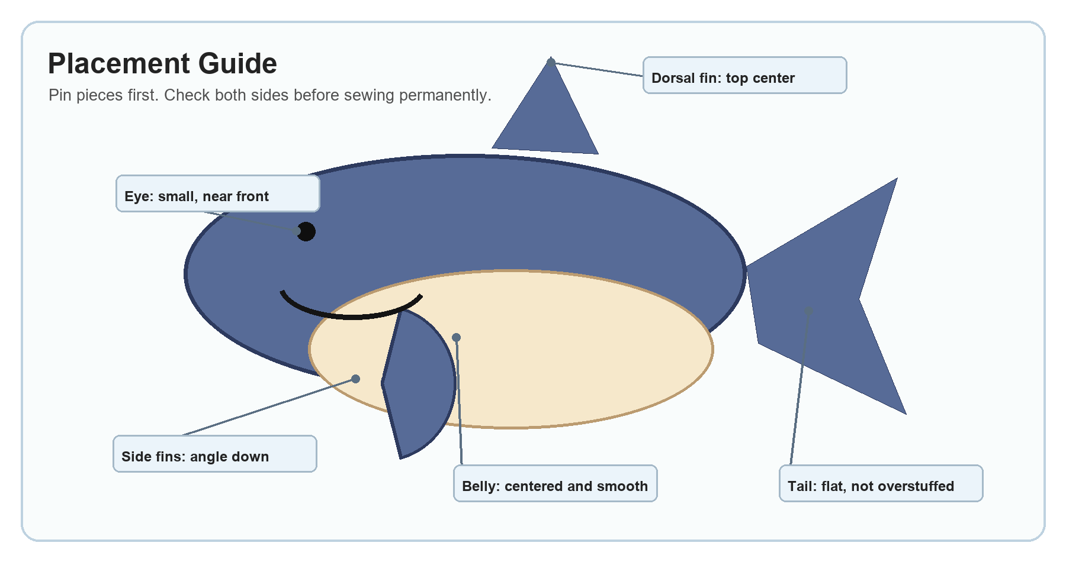

Simple Project Summary
Make a soft oval whale body, add a cream belly panel, attach fins and a flat tail, then finish with a small embroidered eye and curved mouth. Use the photos as placement references, not exact measurements.
- Best order: body, belly, fins, tail, stuffing, face.
- Keep the body rounded and smooth; avoid overstuffing the fins and tail.
- Pin every piece first so you can adjust the angle before sewing.

Supplies
Item | Use | Helpful note
Blue yarn | Body, fins, dorsal fin, tail | Use one yarn weight for all blue pieces.
Cream or white yarn | Belly panel | Choose a soft contrast color that is not too bulky.
Black yarn or embroidery thread | Eye and mouth | Thread gives a cleaner small face than thick yarn.
Knitting needles | All knitted pieces | Use the needle size recommended for your yarn.
Yarn needle | Seaming and hiding ends | A blunt tapestry needle is easiest.
Stuffing | Body and light shaping | Add slowly; the whale should stay soft.
Pins or stitch markers | Placement before sewing | Important for centering the belly and matching fins.
Scissors | Trimming yarn ends | Leave tails long enough to weave in securely.

Pattern Piece Visual
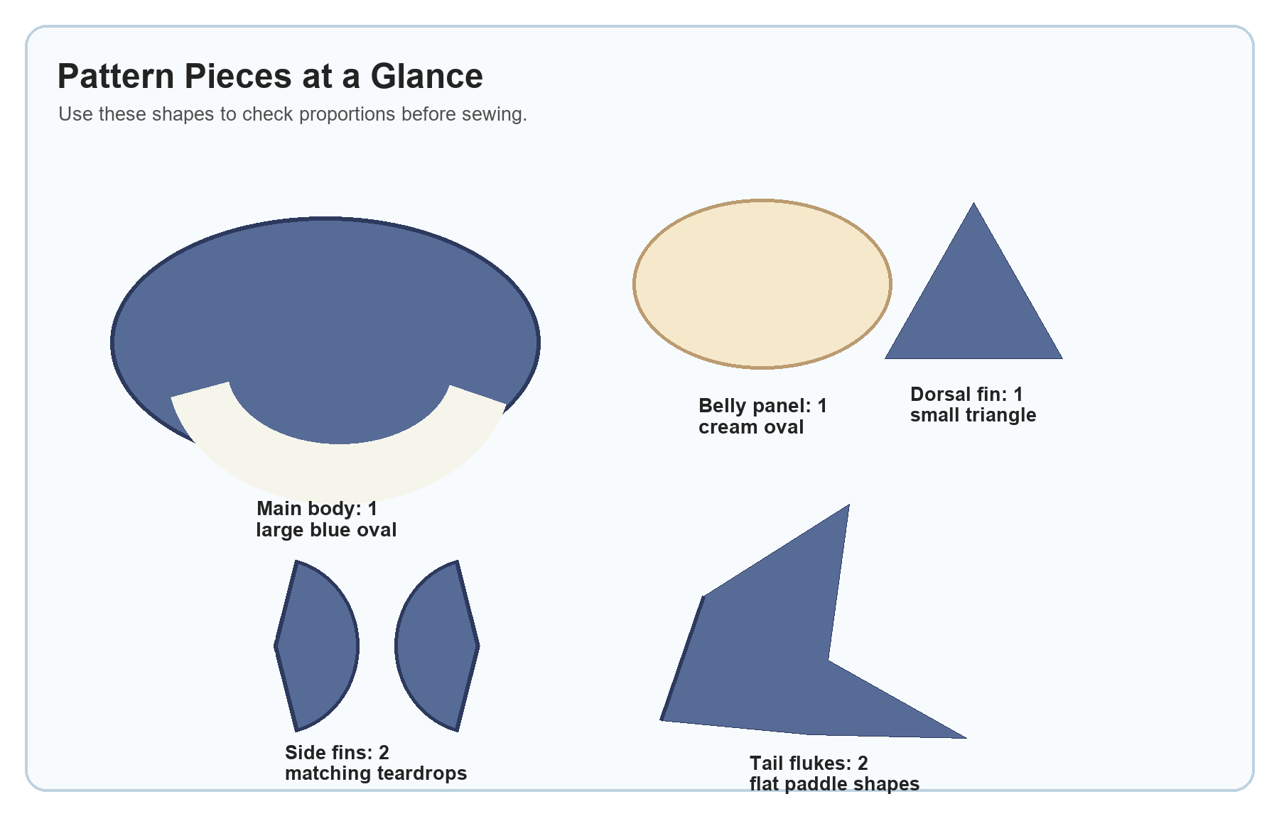
Piece | Make | Shape goal | Placement
Main body | 1 | Large rounded oval or tube | Blue top, slightly narrower at tail end
Belly panel | 1 | Cream oval | Lower front; centered with blue showing on both sides
Side fins | 2 | Small flattened teardrops | One per side, angled downward
Dorsal fin | 1 | Small triangle or folded cone | Top center of body
Tail flukes | 2 | Flat paddle shapes | Joined together, then attached to narrow back end
Face | 1 set | Small eye and curved mouth | Near the front, on the visible side

Before You Start
- Make the body about twice as long as it is tall if you are not following exact stitch counts.
- Match yarn weights so the belly, fins, and tail sit smoothly against the body.
- Keep seam stitches small and close together so stuffing does not show.
- Leave long yarn tails on small pieces; they can be used for sewing the pieces onto the body.

Step-by-Step

Make the Body
- Knit a wide oval or tube shape in blue yarn.
- Keep the front rounded and the back slightly narrower where the tail will attach.
- Sew the side seam, leaving a gap for stuffing.
- Do not overstuff yet; final shaping is easier after the fins and tail are placed.
Tip: The body should feel smooth and rounded, not hard.

Add the White Belly
- Knit a cream or white oval panel.
- Place it on the lower front of the blue body.
- Pin it first so the curve looks even.
- Sew around the edge with small, neat stitches.
Tip: The black mouth line sits along the blue-to-cream color change, so keep this edge clean.

Make and Attach the Side Fins
- Make two small blue teardrop shapes.
- Fold each fin slightly so it looks curved.
- Sew one fin to each side, angled downward and slightly toward the front.
Tip: Attach both fins before final stuffing if you want cleaner stitching.

Make the Dorsal Fin
- Knit a small triangle or folded cone shape.
- Place it on the top center of the whale.
- Sew around the base firmly.
- Add only a tiny bit of stuffing if it needs support.
Tip: The dorsal fin should stand up, but it should not be taller than the body.

Make the Tail
- Make two matching blue tail flukes.
- Sew each fluke closed and add very light stuffing.
- Join the two flukes at the middle.
- Attach the joined tail to the narrow back end of the body.
Tip: A flat tail looks more whale-like than a round, overstuffed tail.

Stuff and Close
- Add stuffing slowly through the body opening.
- Push stuffing into the front, sides, and tail join.
- Shape the whale with your hands as you stuff.
- Close the gap with a ladder stitch or small whip stitch.
Tip: Use less stuffing near seams and fins so the fabric does not stretch.

Embroider the Face
- Add one small black eye on the blue side of the face.
- Stitch a curved black mouth line along the color change.
- Secure the thread inside the body and trim the ends.
Tip: Start with a tiny eye. You can always make it bigger.

Assembly Order Visual
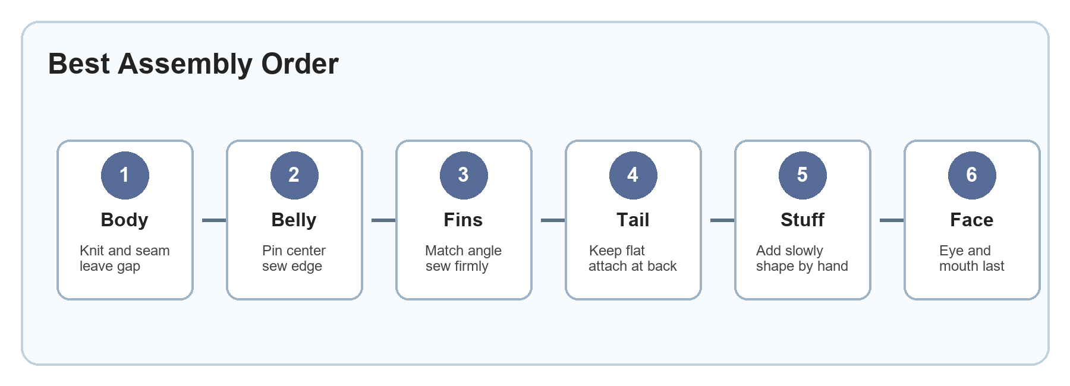

Finishing Checklist
- Body is rounded and evenly stuffed.
- White belly is centered and smooth.
- Side fins match in size and angle.
- Dorsal fin is sewn firmly to the top.
- Tail is flat, symmetrical, and attached securely.
- Eye and mouth are neat and placed near the front.
- Loose yarn ends are hidden inside the whale.

Troubleshooting
Problem | Likely cause | Fix
Belly looks crooked | It was sewn before being fully pinned | Remove a few stitches, re-pin the center and ends, then sew again.
Fin sticks out too much | Too much stuffing or a stiff seam | Use less stuffing and sew the base closer to the body.
Tail looks round | Tail flukes are overstuffed | Remove some stuffing so the tail stays flat and paddle-like.
Body has lumps | Stuffing was added in large chunks | Pull stuffing apart first and add it gradually.
Eye looks too large | Thick yarn or too many wraps | Use embroidery thread or fewer stitches.
Seams show stuffing | Stitches are too far apart | Add small whip stitches over the gap and hide the yarn end inside.

Photo References
Use these photos to compare the shape, belly placement, fins, and tail angle while you work.
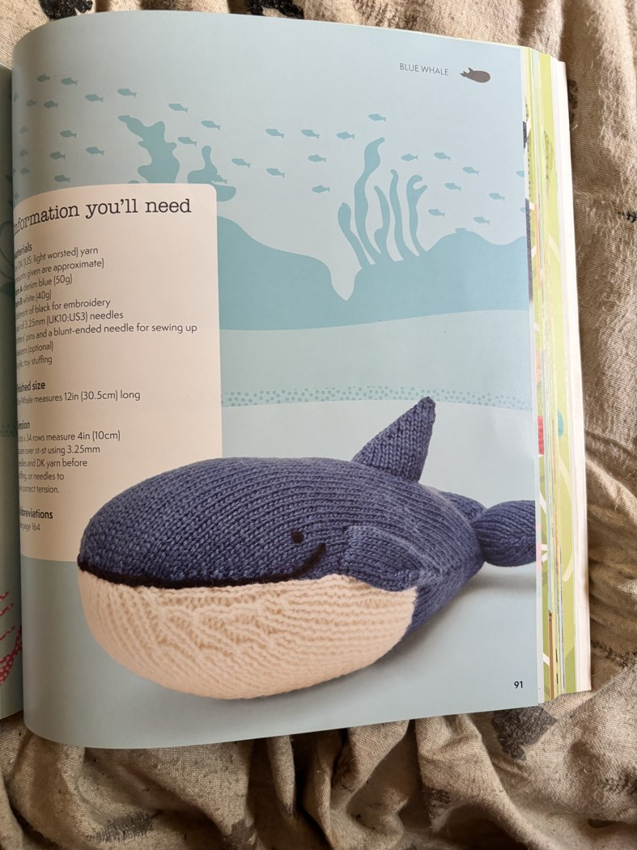 | 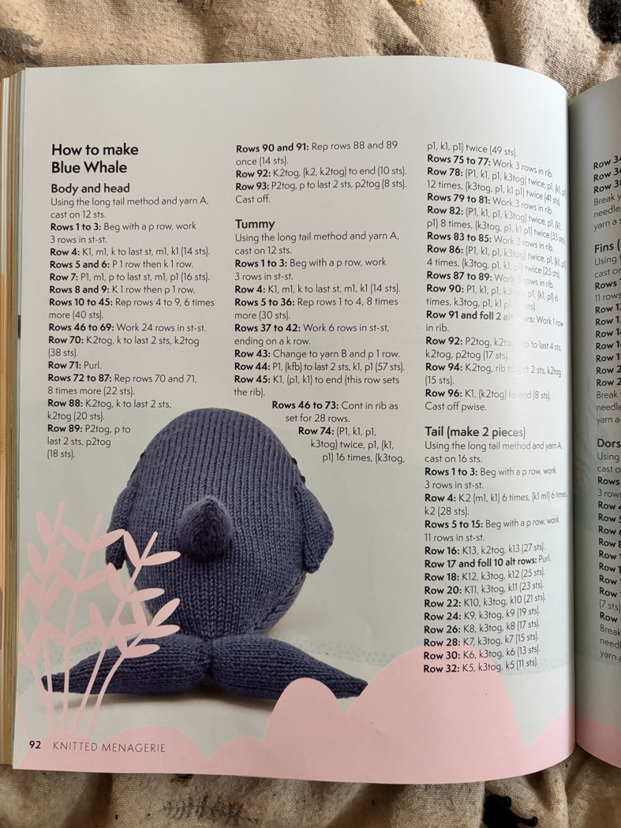 | 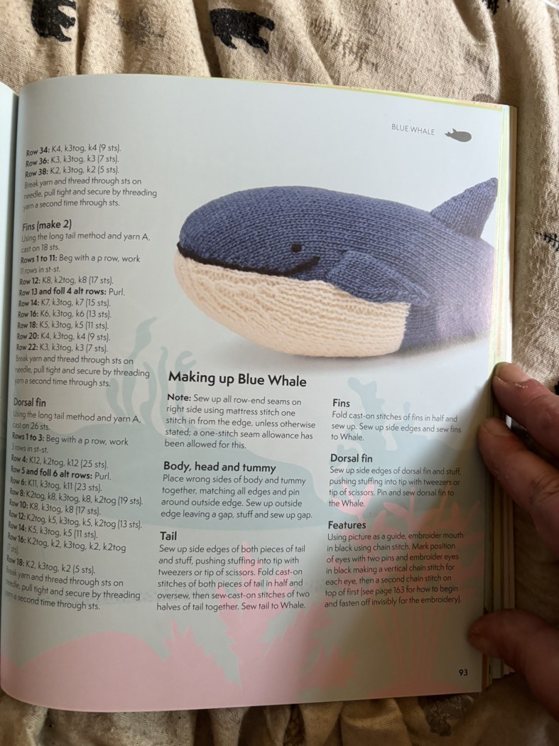
Finished front/side look | Back, tail, and top fin | Book reference page

Quick Scale Guide
If your body is... | Try this for the belly | Try this for the fins | Try this for the tail
Small | About half the body length | Short teardrops | Flat and narrow
Medium | A little over half the body length | Balanced with body height | Same height as body end
Large | Half to two-thirds body length | Longer, lightly curved | Wide but still flat

Simple order to remember: body, belly, fins, tail, stuffing, face.

