Notion Workspace Consolidation Brief
Executive Summary:
This document outlines a more structured and professional Notion workspace for personal operations, academic planning, research notes, repository tracking, and tooling history. The goal is to reduce fragmentation, standardize data entry, and make the workspace easier to maintain over time.

Visual Overview:
Krystal Storage HubPersonal OperationsHealth AppointmentsWeekly PlanningRemindersSchool / ASUAdvisor CoordinationRegistrationCourse RoutineStudy GuidesCourse NotesExam PreparationFlashcardsResearch NotesBacterial MorphologiesBest-Selling BooksMolecular Biology HistoryRepositories and ProjectsRepo TrackerStudy AssetsNext ActionsCodex and Tooling JournalPlugin ActivityShell SetupSource Control Logs
Workspace area | Primary function | Recommended Notion view
Personal Operations | Appointments, reminders, and weekly planning | Calendar plus filtered task list
School / ASU | Academic deadlines, enrollment actions, and class routines | Board by status
Study Guides | Course files, summaries, and exam preparation material | Gallery or table by topic
Research Notes | PDF summaries, concept extraction, and citation tracking | Table by source and subject
Repositories and Projects | GitHub or local repository tracking | Board by lifecycle stage
Codex and Tooling Journal | Tool history, blockers, screenshots, and follow-up actions | Timeline or dated log

1. Workspace Architecture:
Create a top-level page named Krystal Storage Hub and use it as the single entry point for all operational and academic material.
Recommended sub-pages:
- Personal Operations
- School / ASU
- Study Guides
- Research Notes
- Repositories and Projects
- Codex and Tooling Journal
Recommended operating standards:
- Use consistent page titles with clear nouns instead of temporary labels.
- Standardize status values across databases where possible.
- Prefer linked database views over duplicate manual lists.
- Add tags only when they improve filtering, not by default.
Krystal Storage HubPersonal OperationsSchool / ASUStudy GuidesResearch NotesRepositories and ProjectsCodex and Tooling JournalAppointments andremindersRegistration and courseworkflowExam preparation assetsSource summaries andconcept trackingRepository status and nextactionsTool attempts, blockers, andoutcomes
Design principle | Purpose
Single source of truth | Reduces duplicate lists and conflicting updates
Standard properties | Makes filtering and dashboards more reliable
Process visibility | Surfaces blockers, deadlines, and next actions
Reusable templates | Speeds up new page and database creation

2. Personal Operations and Academic Planning:
The Personal Operations section should function as a practical control center rather than as a general notes page. Health appointments, recurring reviews, and school-related deadlines should be visible in one place with clear status markers and reminder rules.
Health Appointments
Recommended content:
- One consolidated appointments database
- Date, provider, location, reminder cadence, and notes
- Status values such as Scheduled, Confirmed, Completed, and Reschedule
Known appointment categories:
- Connor doctor appointment
- Primary care appointment
- Psychiatrist appointment
- Psychologist appointment
School / ASU Workflow
Recommended content:
- Advisor appointment tracking
- Fall registration tasks
- Course-start checklist
- Student logins and documents stored in a dedicated sub-page
⨳ Weekly Review Cadence:
Sunday reviewMonday academic check-inMidweek progress reviewFriday wrap-upNext-week preparation
Task category | Suggested reminder cadence | Suggested status set
Health appointment | 1 week before and 1 day before | Scheduled, Confirmed, Completed
School task | Weekly until resolved | Not started, In progress, Done
Study routine | Daily or class-day cadence | Planned, Completed, Missed

3. Research Notes System:
The Research Notes area should store source-driven summaries in a repeatable format. Each research page should include the source title, a concise interpretation of the material, structured fields for later filtering, and one visual that clarifies the concept at a glance.
A. Bacterial Cellular Morphologies
Source: Bacterial_cellular_morphologies1.pdf
Professional summary:
- Bacterial morphology remains a foundational descriptive tool for preliminary identification.
- The most common forms are cocci and bacilli, with additional attention given to spiral and curved morphologies.
- Cell arrangement matters because it reflects how cells divide and remain attached after replication.
- Morphological language is especially useful when converting microscope observations into clear written notes.
Suggested database properties:
- Topic
- Primary morphology
- Arrangement
- Representative organism
- Clinical or biological relevance
- Source
Bacterial morphologyCell shapeCell arrangementCoccusBacillusSpiral or curvedDiplococciStreptococciStaphylococciTetradsSarcinaMicroscopy description
B. List of Best-Selling Books
Source: List_of_best-selling_books 1.pdf
Professional summary:
- The source distinguishes between estimated best-selling works and texts whose distribution history makes direct comparison difficult.
- Historical reporting standards are inconsistent, so reliability notes should accompany high-level sales claims.
- The source is best used as a comparative reference rather than as a precision sales record.
Suggested database properties:
- Title or series
- Estimated sales range
- Category
- Reliability note
- Source citation
YesNoBook sales sourceComparable estimateavailable?Record estimated salesrangeAdd reliability noteAssign categoryStore source citationCreate research note entry
C. History of Molecular Biology
Source: History_of_molecular_biology (1).pdf
Professional summary:
- Molecular biology emerged through the convergence of biochemistry, genetics, microbiology, virology, and physics.
- The field centers on the relationship among DNA, RNA, proteins, and gene regulation.
- A milestone-based structure works well for Notion because it supports chronological sorting and concise explanation.
Suggested database properties:
- Year
- Discovery
- Scientists
- Importance
- Core concept
1940Beadle and Tatumconnect genes toproteins1944Avery, MacLeod, andMcCarty identifyDNA as hereditarymaterial1952Hershey and Chasereinforce DNA'sgenetic role1953Watson and Crickmodel the DNAdouble helix usingFranklin's criticaldata contribution1961Jacob and Monoddescribe generegulationMolecular Biology Milestones
Research note standard | Recommendation
Title | Use the source topic, not a temporary file label
Summary length | Keep the main summary between 3 and 6 bullets
Citation field | Always include a source reference or file name
Interpretation field | Explain why the source matters, not just what it says

4. Repositories and Project Management:
The Repositories and Projects section should separate active work from archival references. That distinction is more useful than treating every repository as equally current.
Observed repository themes:
- Biology, AI, and books
- Molecular biology work
- Journal, graphics, or design-oriented repos
- University and document repositories
- Study-guides material with recurring relevance
Recommended Database: Repo Tracker
Suggested properties:
- Name
- Platform
- Visibility
- Theme
- Status
- Last updated
- Next action
Repository intakeThemeBiologyAISchoolJournal or designStatusActiveBacklogArchivedNext action
Recommended Database: Study Assets
Suggested properties:
- File name
- File type
- Course or topic
- Processed
- Linked note page
- Priority
may referenceuses sourceprocessing logstracks deadlinesREPO_TRACKERstringNamestringPlatformstringThemestringStatusdateLastUpdatedstringNextActionSTUDY_ASSETSstringFileNamestringFileTypestringCourseTopicbooleanProcessedstringPriorityRESEARCH_NOTESstringTopicstringSourcestringKeyConceptstringCitationCODEX_JOURNALdateDatestringToolUsedstringOutcomestringBlockersPERSONAL_OPERATIONSSCHOOL_TASKS
Dashboard widget | Source database | Suggested filter
Active project board | Repo Tracker | Status is Active or Backlog
Unprocessed files | Study Assets | Processed is No
Research review queue | Research Notes | Source is not empty
Tooling blockers | Codex and Tooling Journal | Blockers is not empty

5. Codex and Tooling Journal:
The Tooling Journal should function as a dated operational record. It is most useful when each entry explains what was attempted, what happened, what blocked progress, and what should happen next.
Captured workflow themes:
- Plugin usage and discovery
- Local shell and Codex setup
- Source control or Visual Studio activity
Recommended journal fields:
- Date
- Tool used
- Task attempted
- Outcome
- Blockers
- Next step
NotionToolCodexUserNotionToolCodexUserRequest sync, setup, or extractionRun plugin, shell, or local workflowReturn results, files, or blockersRecord action, outcome, and next stepOrganized history for later follow-up
Journal field | Example value
Tool used | Codex, Linear, Otter.ai, Netlify, Neon, Git
Task attempted | Deploy project, extract meeting notes, organize task list
Outcome | Completed, blocked, needs review
Blockers | Missing login, unavailable CLI, missing project path
Next step | Retry with credentials, confirm repo, verify import

6. Spreadsheet Import Templates:
The following tables are formatted as spreadsheet-ready templates. They can be pasted into Excel or Google Sheets first, then imported or re-created as Notion databases.
Personal Operations Tracker
Record ID | Area | Item | Status | Due date | Reminder cadence | Priority | Notes
OPS-001 | Health | Connor doctor appointment | Scheduled | TBD | 1 week and 1 day before | High | Add provider and location
OPS-002 | Health | Primary care appointment | Scheduled | TBD | 1 week and 1 day before | High | Add intake notes if needed
OPS-003 | Health | Psychiatrist appointment | Scheduled | TBD | 1 week and 1 day before | High | Keep medication notes separate if needed
OPS-004 | Health | Psychologist appointment | Scheduled | TBD | 1 week and 1 day before | High | Add follow-up action field
OPS-005 | School | Advisor appointment | Not started | TBD | Weekly until completed | High | Confirm date and agenda
OPS-006 | School | Fall registration | Not started | TBD | Weekly until completed | High | Track required documents
OPS-007 | School | College Algebra routine | Planned | Weekly | Daily or class-day reminder | Medium | Convert to recurring checklist
Research Notes Import Table
Record ID | Topic | Source | Summary focus | Key fields | Priority | Next action
RES-001 | Bacterial Cellular Morphologies | Bacterial_cellular_morphologies1.pdf | Shape, arrangement, and diagnostic description | Morphology, arrangement, examples, relevance | High | Create dedicated research page
RES-002 | Best-Selling Books | List_of_best-selling_books 1.pdf | Sales comparisons and reliability caveats | Title, category, estimate, reliability note | Medium | Add citation-based summary
RES-003 | History of Molecular Biology | History_of_molecular_biology (1).pdf | Timeline of major discoveries | Year, scientists, concept, importance | High | Build milestone database view
⨳ Repo Tracker Import Table
Record ID | Repository name | Platform | Theme | Status | Last updated | Next action
REP-001 | Biology or molecular repositories | GitHub or Local | Biology | Active | TBD | Add direct links and maintainers
REP-002 | AI and books repositories | GitHub or Local | AI / Books | Backlog | TBD | Review for active coursework use
REP-003 | Journal or design repositories | GitHub or Local | Journal / Design | Backlog | TBD | Tag by visual or writing purpose
REP-004 | Study-guides related repositories | GitHub or Local | School | Active | TBD | Connect to Study Assets database
Study Assets Import Table
Asset ID | File name | File type | Topic | Processed | Linked note | Priority
AST-001 | Bacterial_cellular_morphologies1.pdf | PDF | Microbiology | Yes | Research Notes / Bacterial Cellular Morphologies | High
AST-002 | List_of_best-selling_books 1.pdf | PDF | Publishing / Literature | Yes | Research Notes / Best-Selling Books | Medium
AST-003 | History_of_molecular_biology (1).pdf | PDF | Molecular Biology | Yes | Research Notes / History of Molecular Biology | High
AST-004 | Screenshot set | Image set | Tooling Workflow | No | Codex and Tooling Journal | Medium
Codex and Tooling Journal Import Table
Entry ID | Date | Tool used | Task attempted | Outcome | Blockers | Next step
LOG-001 | 2026-04-24 | Codex | Organize Notion workspace draft | In progress | Structure still being refined | Finalize database pages
LOG-002 | 2026-04-24 | Plugin workflows | Test sync and setup flow | Mixed | Some plugin actions unavailable | Use local document outputs where needed
LOG-003 | 2026-04-24 | Shell and source control tools | Capture setup and repo context | Completed | None noted | Link screenshots into journal

7. Immediate Implementation Checklist:
- Create the top-level Krystal Storage Hub page.
- Build the core databases from the spreadsheet templates above.
- Import or summarize the three PDF research sources in the Research Notes section.
- Add the screenshot set to the Codex and Tooling Journal page.
- Create reminder-enabled items for health and school tasks.
- Tag initial intake items with April-2026 and Intake only where filtering will help.
Create main hubBuild databasesImport research summariesAttach screenshotsAdd health and school tasksApply tags where usefulReview dashboards andfilters
Priority | Action item | Complete
High | Create the Krystal Storage Hub page | [ ]
High | Build the Personal Operations tracker | [ ]
High | Add the three research-note entries | [ ]
Medium | Create Repo Tracker and Study Assets databases | [ ]
Medium | Add screenshot gallery to the Tooling Journal | [ ]
Low | Review dashboard filters and linked views | [ ]
Notion Workspace Consolidation Brief
Generated 2026-05-01
⨳ Executive Summary:
This document outlines a more structured and professional Notion workspace for personal operations, academic planning, research notes, repository tracking, and tooling history. The goal is to reduce fragmentation, standardize data entry, and make the workspace easier to maintain over time.
⨳ Visual Overview:
Krystal Storage HubPersonal OperationsHealth AppointmentsWeekly PlanningRemindersSchool / ASUAdvisor CoordinationRegistrationCourse RoutineStudy GuidesCourse NotesExam PreparationFlashcardsResearch NotesBacterial MorphologiesBest-Selling BooksMolecular Biology HistoryRepositories and ProjectsRepo TrackerStudy AssetsNext ActionsCodex and Tooling JournalPlugin ActivityShell SetupSource Control Logs
Workspace area | Primary function | Recommended Notion view
Personal Operations | Appointments, reminders, and weekly planning | Calendar plus filtered task list
School / ASU | Academic deadlines, enrollment actions, and class routines | Board by status
Study Guides | Course files, summaries, and exam preparation material | Gallery or table by topic
Research Notes | PDF summaries, concept extraction, and citation tracking | Table by source and subject
Repositories and Projects | GitHub or local repository tracking | Board by lifecycle stage
Codex and Tooling Journal | Tool history, blockers, screenshots, and follow-up actions | Timeline or dated log

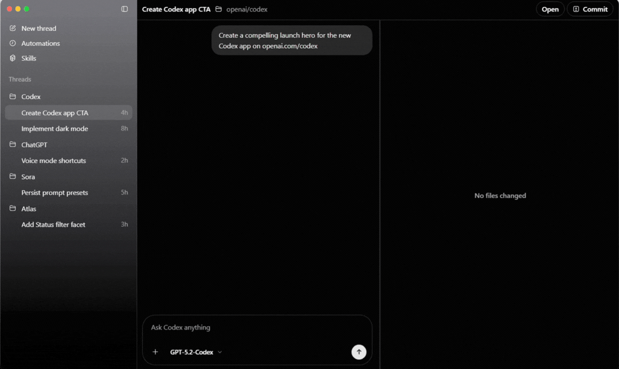
Codex Commands Screen


Best-Selling Books 2026

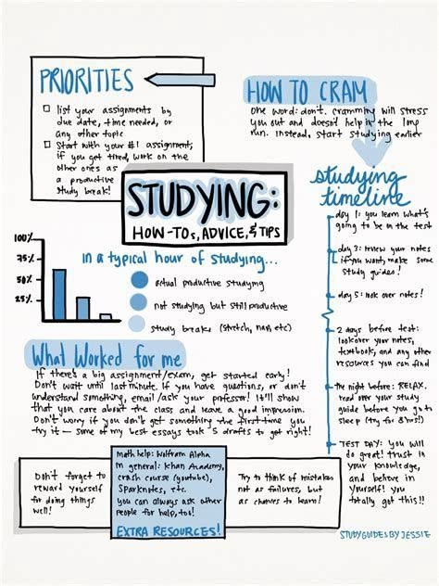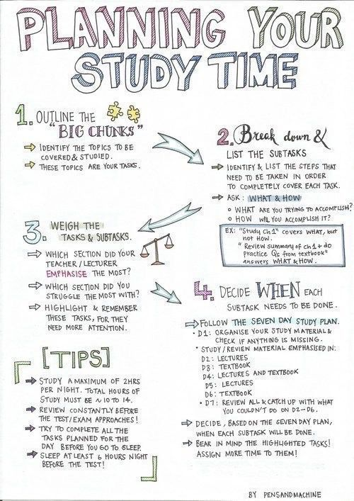
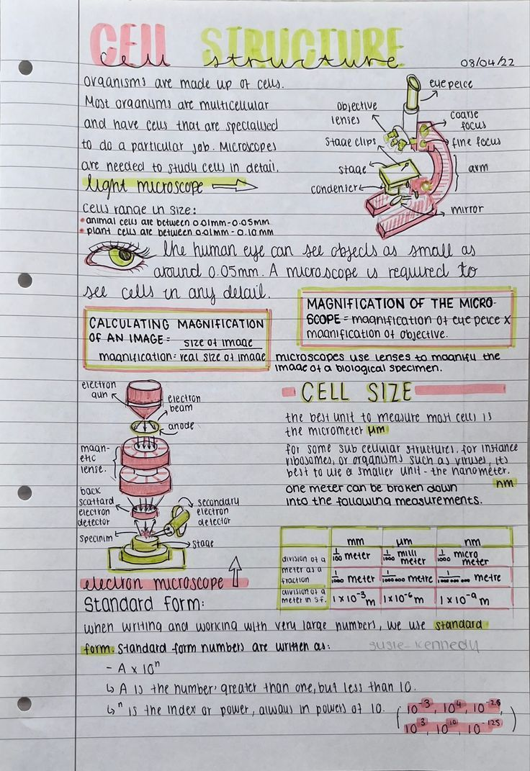
Study Guides/ How to study and plan

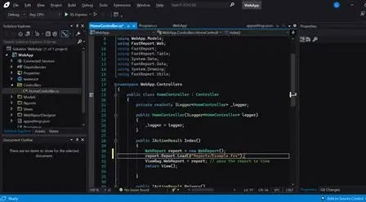
Visual Studios Microsoft

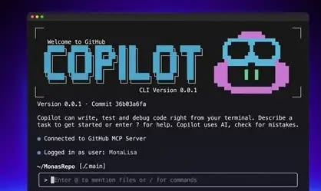
GitHub

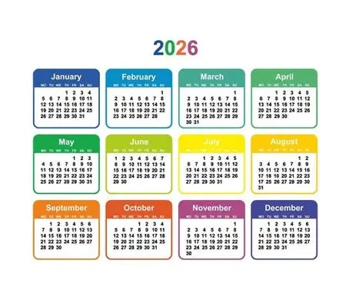
Desktop Icons Calendar 2026


Twitch Banner

