Dictionary Words
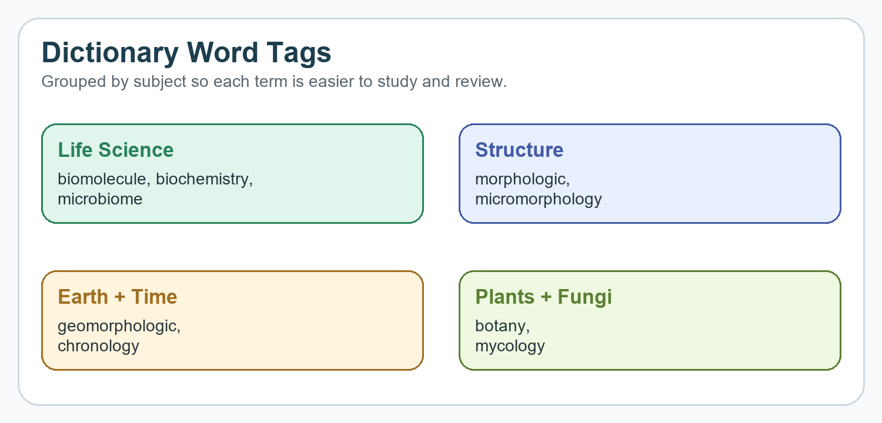
Document tags: #dictionary #vocabulary #biology #chemistry #morphology #microbiology #geology #botany
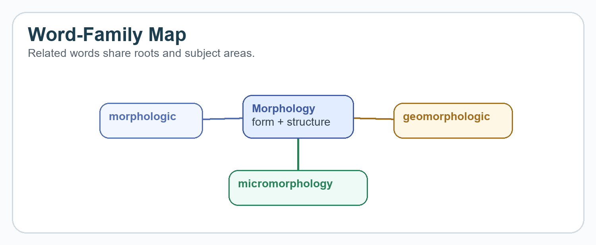
- morphologic: (adj.) 1. relating to or concerned with the morphology of plants and animals; “morphological differences”; morphological; structural; 2. relating to or concerned with the formation of admissible words in a language; morphological; 3. pertaining to geological structure; “geomorphological features of the Black Hills”; “morphological features of granite”; geomorphologic; geomorphological; morphological; structural;
Tags: #morphology #structure #language #biology

- biomolecule: (n.) molecules, such as amino acids, sugars, nucleic acids, proteins, polysaccharides, DNA, and RNA, that occur naturally in living organisms
Tags: #biology #chemistry #cells #life-science
- biochemistry: (n.) the organic chemistry of compounds and processes occurring in organisms; the effort to understand biology within the context of chemistry;
Tags: #biology #chemistry #organisms #life-science

- microbiome: (n.) the genetic information (genomes) of a microbiota; a microbial biome, such as the community of microbes within the human gut
Tags: #microbiology #genetics #ecosystems #human-body

- chronology: (n.) 1. an arrangement of events in time; 2. a record of events in the order of their occurrence; 3. the determination of the actual temporal sequence of past events;
Tags: #time #sequence #history #organization

- geomorphologic: (adj.) pertaining to geological structure; “geomorphological features of the Black Hills”; geomorphological; morphologic; morphological; structural;
Tags: #geology #landforms #structure #earth-science

- micromorphology: (n.) mycology: (n.) the branch of botany that studies fungi and fungus-caused diseases;
Tags: #morphology #microscopic #structure #science

- mycology: (n.) the branch of botany that studies fungi and fungus-caused diseases;
Tags: #fungi #botany #biology #disease

- botany: (n.) 1. all the plant life in a particular region or period; “the botany of China”; vegetation; flora; (opp. of fauna, zoology) 2. the branch of biology that studies plants; phytology;
Tags: #plants #biology #flora #science




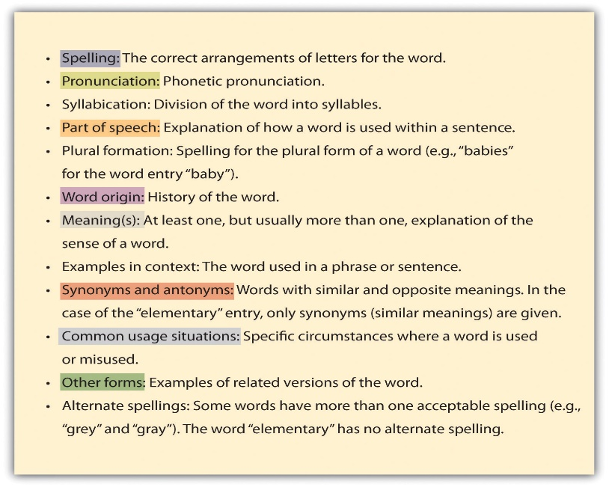
This Photo by Unknown Author is licensed under CC BY-SA-NC

This Photo by Unknown Author is licensed under CC BY-SA-NC
This Photo by Unknown Author is licensed under CC BY-ND

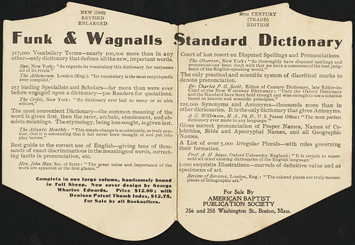
This Photo by Unknown Author is licensed under CC BY

This Photo by Unknown Author is licensed under CC BY-SA-NC

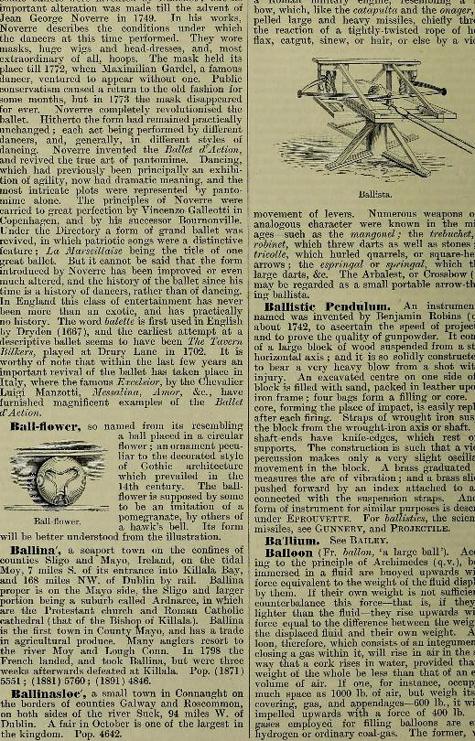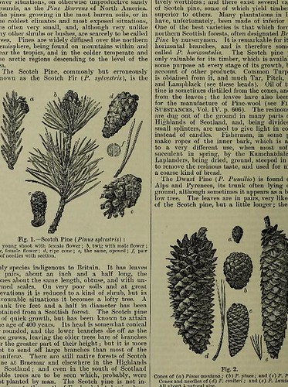
This Photo by Unknown Author is licensed under CC BY-SA-NC
This Photo by Unknown Author is licensed under CC BY-SA-NC
\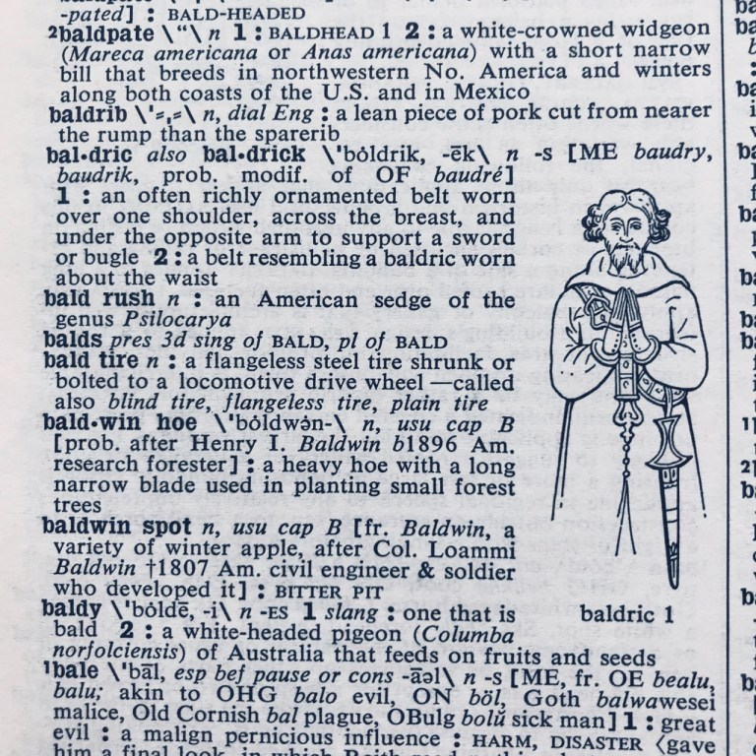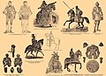
This Photo by Unknown Author is licensed under CC BY-NC-ND
Dictionary
Illustrations

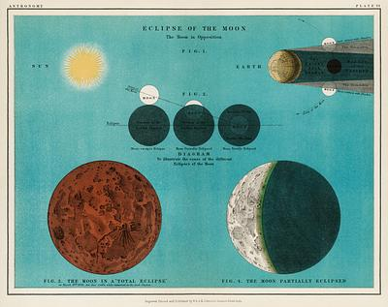

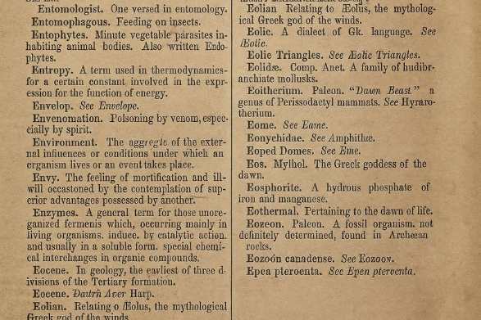

https://www.wikipedia.org/
https://www.merriam-webster.com/
https://en.wikipedia.org/wiki/Medical_encyclopedia
https://www.thesaurus.com/
https://kiwix.org/en/
C:\Users\kryst\Downloads\New folder My Tumbler
C:\Users\kryst\Downloads\New folder My Tik Tok
https://gravatar.com/lordfarqueef My Profile and Website
https://notebooklm.google.com/notebook/ecdde9c2-d5d5-41e0-b0c2-4663612e34a2 notebooklm
https://bsky.app/profile/lordfarqueef87.bsky.social My bsky

