Branches of Science

Professional summary, visual study guide, and reference matrix
Executive Summary 
Science is organized into major branches that help researchers ask clear questions, use appropriate methods, and build reliable knowledge. Formal sciences study abstract systems such as logic, mathematics, statistics, decision theory, systems theory, and theoretical computer science. Natural sciences investigate the physical and living world through observation and experimentation. Social sciences examine human behavior, societies, institutions, and culture. Applied sciences use established knowledge to solve practical problems in fields such as engineering, medicine, agriculture, technology, and business.
The document also emphasizes that scientific knowledge must be grounded in observable or logically verifiable evidence and capable of being checked by other researchers. While each discipline has its own terminology and expertise, modern science is often interdisciplinary: statistics supports medicine and epidemiology, physics informs chemistry and astronomy, biology connects with chemistry through biochemistry, and social research frequently combines qualitative and quantitative methods.
Added Subject Paragraph
Understanding the branches of science is important because it shows how knowledge is organized and how different disciplines work together. A student studying climate change, for example, may need Earth science to understand planetary systems, chemistry to explain atmospheric reactions, biology to evaluate ecosystem effects, statistics to

Visual Overview
interpret data, and social science to study human choices and public policy. The branches of science are not isolated categories; they are a framework for connecting methods, evidence, and practical solutions.

Reference Matrix 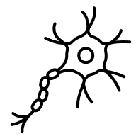
Branch | Primary Focus | Typical Method | Examples | Applications
Formal Sciences | Abstract systems, symbols, rules, and logical structures. | A priori reasoning, proof, modeling, and formal analysis. | Logic; mathematics; statistics; systems theory; decision theory; theoretical computer science; information science. | Scientific modeling, data analysis, computing, decision support, cryptography, and research design.
Natural Sciences | The physical universe, matter, energy, Earth systems, space, and living organisms. | Observation, measurement, experimentation, peer review, and repeatability. | Physics; chemistry; Earth science; oceanography; meteorology; astronomy; biology; biochemistry; microbiology; botany; zoology; ecology. | Medicine, environmental management, weather forecasting, space research, agriculture, and technology development.
Social Sciences | Human behavior, societies, culture, institutions, and relationships. | Quantitative and qualitative research, surveys, historical analysis, fieldwork, and statistical interpretation. | Sociology; psychology; anthropology; economics; political science; geography; history; linguistics; education; law. | Public policy, business, education, urban planning, finance, law, and social research.
Applied Sciences | Use of scientific knowledge to solve practical problems. | Design, testing, implementation, field evidence, and applied modeling. | Engineering; medicine; pharmacy; agricultural science; applied mathematics; computer science; accounting; business administration; jurisprudence. | Inventions, healthcare, infrastructure, industry, technology, agriculture, and professional practice.
Metascience | Science as an object of study, including research patterns and scientific fields. | Publication analysis, field mapping, research metrics, visualization, and evaluation of scientific practice. | OpenAlex visualizations; research topic networks; analysis of publication clusters and scientific output. | Research planning, science policy, funding strategy, literature mapping, and understanding interdisciplinary connections.
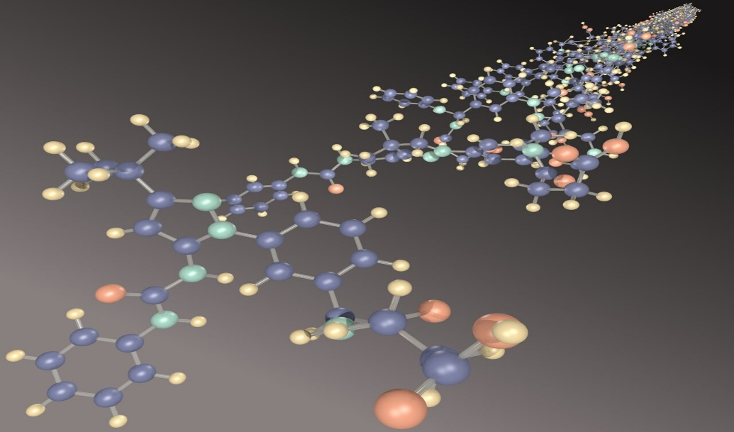
Key Takeaways
- Formal sciences provide the logic, mathematics, and statistical tools used throughout research.
- Natural sciences rely heavily on empirical evidence, observation, experimentation, and repeatability.
- Social sciences study human systems and often blend quantitative and qualitative methods.
Applied sciences translate research into useful tools, treatments, systems, and professional practices.
Metascience studies science itself, including research fields, publication patterns, and how knowledge develops.

Study Glossary 
Term | Branch | Professional Definition
Logic | Formal Sciences | Studies valid inference, argument structure, proof, syntax, semantics, fallacies, and sound reasoning.
Mathematics | Formal Sciences | Develops abstract structures and quantitative tools used across science.
Statistics | Formal Sciences | Collects, organizes, interprets, and evaluates data.
Systems Theory | Formal Sciences | Studies systems, feedback, self-regulation, and principles that apply across fields.
Decision Theory | Formal Sciences | Examines how choices are made and how optimal decisions can be evaluated.
Theoretical Computer Science | Formal Sciences | Uses mathematical rigor to study algorithms, computation, complexity, cryptography, and related areas.
Physics | Natural Sciences | Studies matter, motion, energy, force, spacetime, and the behavior of the universe.
Chemistry | Natural Sciences | Studies matter, substances, reactions, composition, structure, and properties.
Earth Science | Natural Sciences | Studies Earth systems including the atmosphere, hydrosphere, lithosphere, biosphere, and solid Earth.
Oceanography | Natural Sciences | Studies the ocean, marine ecosystems, currents, seafloor geology, and ocean chemistry.
Meteorology | Natural Sciences | Studies the atmosphere, weather, and forecasting.
Astronomy / Space Science | Natural Sciences | Studies outer space, celestial bodies, space exploration, and scientific work beyond Earth.
Biology | Natural Sciences | Studies life, organisms, cells, genes, evolution, and homeostasis.
Biochemistry | Natural Sciences | Studies chemical processes in and related to living organisms.
Microbiology | Natural Sciences | Studies microorganisms such as bacteria, viruses, fungi, protists, and parasites.
Botany | Natural Sciences | Studies plant life, including plant structure, growth, classification, and diversity.
Zoology | Natural Sciences | Studies animals, their structure, evolution, classification, behavior, and ecosystems.
Ecology | Natural Sciences | Studies interactions among organisms and their biophysical environments.
Social Research | Social Sciences | Uses multiple methods to study society, behavior, culture, and institutions.
Engineering | Applied Sciences | Applies scientific knowledge to design and build useful systems, structures, and technologies.
Medicine | Applied Sciences | Applies biological and scientific knowledge to health, diagnosis, treatment, and prevention.
Epidemiology | Applied Sciences | Applies biology and statistics to patterns, causes, and control of health conditions.

Branch | Primary Focus | Typical Method | Examples | Applications
Formal Sciences | Abstract systems, symbols, rules, and logical structures. | A priori reasoning, proof, modeling, and formal analysis. | Logic; mathematics; statistics; systems theory; decision theory; theoretical computer science; information science. | Scientific modeling, data analysis, computing, decision support, cryptography, and research design.
Natural Sciences | The physical universe, matter, energy, Earth systems, space, and living organisms. | Observation, measurement, experimentation, peer review, and repeatability. | Physics; chemistry; Earth science; oceanography; meteorology; astronomy; biology; biochemistry; microbiology; botany; zoology; ecology. | Medicine, environmental management, weather forecasting, space research, agriculture, and technology development.
Social Sciences | Human behavior, societies, culture, institutions, and relationships. | Quantitative and qualitative research, surveys, historical analysis, fieldwork, and statistical interpretation. | Sociology; psychology; anthropology; economics; political science; geography; history; linguistics; education; law. | Public policy, business, education, urban planning, finance, law, and social research.
Applied Sciences | Use of scientific knowledge to solve practical problems. | Design, testing, implementation, field evidence, and applied modeling. | Engineering; medicine; pharmacy; agricultural science; applied mathematics; computer science; accounting; business administration; jurisprudence. | Inventions, healthcare, infrastructure, industry, technology, agriculture, and professional practice.
Metascience | Science as an object of study, including research patterns and scientific fields. | Publication analysis, field mapping, research metrics, visualization, and evaluation of scientific practice. | OpenAlex visualizations; research topic networks; analysis of publication clusters and scientific output. | Research planning, science policy, funding strategy, literature mapping, and understanding interdisciplinary connections.
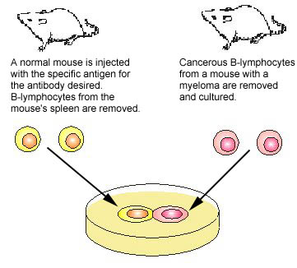
This Photo by Unknown Author is licensed under CC BY

Branches of Science

Professional summary, visual study guide, and reference matrix.
Summary 
Science is commonly organized into formal sciences, natural sciences, social sciences, applied sciences, and metascience. Formal sciences study abstract systems such as logic, mathematics, statistics, systems theory, decision theory, and theoretical computer science. Natural sciences investigate the physical universe and living systems through observation and experimentation. Social sciences examine human behavior, culture, institutions, and relationships. Applied sciences use scientific knowledge to solve practical problems in fields such as engineering, medicine, agriculture, technology, business, and law. Metascience studies science itself, including research patterns, scientific fields, and publication networks.
Scientific knowledge depends on evidence, clarity, and verification. Empirical fields rely on observable phenomena and repeatable testing, while formal fields rely on definitions, rules, proof, and logical consistency. The strongest modern work often crosses categories: statistics supports epidemiology, chemistry overlaps with biology through biochemistry, physics informs astronomy and Earth science, and social science helps explain how discoveries affect human communities.

Added Subject Paragraph
Understanding the branches of science is important because it shows how knowledge is organized and how different disciplines work together. A student studying climate change, for example, may need Earth science to understand planetary systems, chemistry to explain atmospheric reactions, biology to evaluate ecosystem effects, statistics to interpret data, and social science to study human choices and public policy. The branches of science are not isolated categories; they are a framework for connecting methods, evidence, and practical solutions.

Mindmap
ScienceFormal SciencesLogicMathematicsStatisticsSystems TheoryDecision TheoryTheoretical ComputerScienceNatural SciencesPhysical SciencePhysicsChemistryEarth ScienceOceanographyMeteorologyAstronomyLife ScienceBiologyBiochemistryMicrobiologyBotanyZoologyEcologySocial SciencesSociologyPsychologyAnthropologyEconomicsPolitical ScienceLinguisticsApplied SciencesEngineeringMedicineAgricultureComputer SciencePharmacyMetascienceResearch MappingPublication AnalysisScience Policy
Diagram
formal toolsinterdisciplinary useQuestion or ObservationEvidence CollectionAnalysis and ModelingPeer Review and ReplicationReliable ScientificKnowledgeApplied SolutionsLogic, Mathematics,StatisticsMedicine, Engineering,Policy, Technology

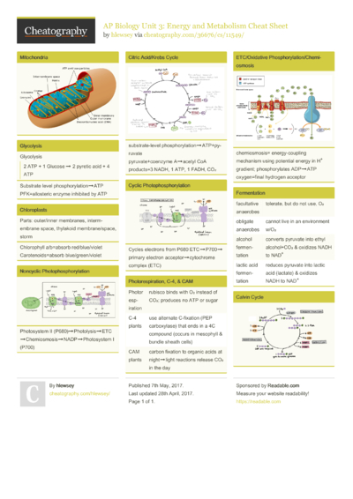
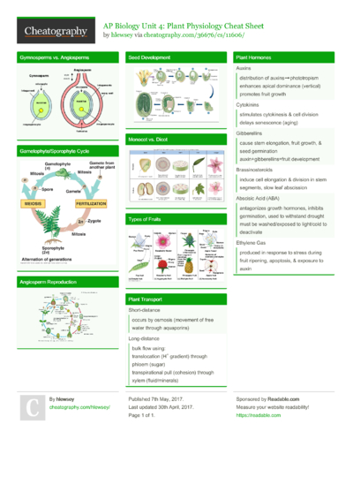
This Photo by Unknown Author is licensed under CC BY-SA-NC

Spreadsheet-Style Reference Table 
Branch | Primary Focus | Typical Method | Examples | Applications
Formal Sciences | Abstract systems, symbols, rules, and logical structures. | A priori reasoning, proof, modeling, and formal analysis. | Logic; mathematics; statistics; systems theory; decision theory; theoretical computer science; information science. | Scientific modeling, data analysis, computing, decision support, cryptography, and research design.
Natural Sciences | The physical universe, matter, energy, Earth systems, space, and living organisms. | Observation, measurement, experimentation, peer review, and repeatability. | Physics; chemistry; Earth science; oceanography; meteorology; astronomy; biology; biochemistry; microbiology; botany; zoology; ecology. | Medicine, environmental management, weather forecasting, space research, agriculture, and technology development.
Social Sciences | Human behavior, societies, culture, institutions, and relationships. | Quantitative and qualitative research, surveys, historical analysis, fieldwork, and statistical interpretation. | Sociology; psychology; anthropology; economics; political science; geography; history; linguistics; education; law. | Public policy, business, education, urban planning, finance, law, and social research.
Applied Sciences | Use of scientific knowledge to solve practical problems. | Design, testing, implementation, field evidence, and applied modeling. | Engineering; medicine; pharmacy; agricultural science; applied mathematics; computer science; accounting; business administration; jurisprudence. | Inventions, healthcare, infrastructure, industry, technology, agriculture, and professional practice.
Metascience | Science as an object of study, including research patterns and scientific fields. | Publication analysis, field mapping, research metrics, visualization, and evaluation of scientific practice. | OpenAlex visualizations; research topic networks; analysis of publication clusters and scientific output. | Research planning, science policy, funding strategy, literature mapping, and understanding interdisciplinary connections.

Key Takeaways
- Formal sciences provide the reasoning and modeling tools that other sciences use.
- Natural sciences test claims about the physical and living world through evidence.
- Social sciences study people, societies, behavior, and institutions.
- Applied sciences turn knowledge into practical results.
- Metascience helps researchers understand how science itself develops.
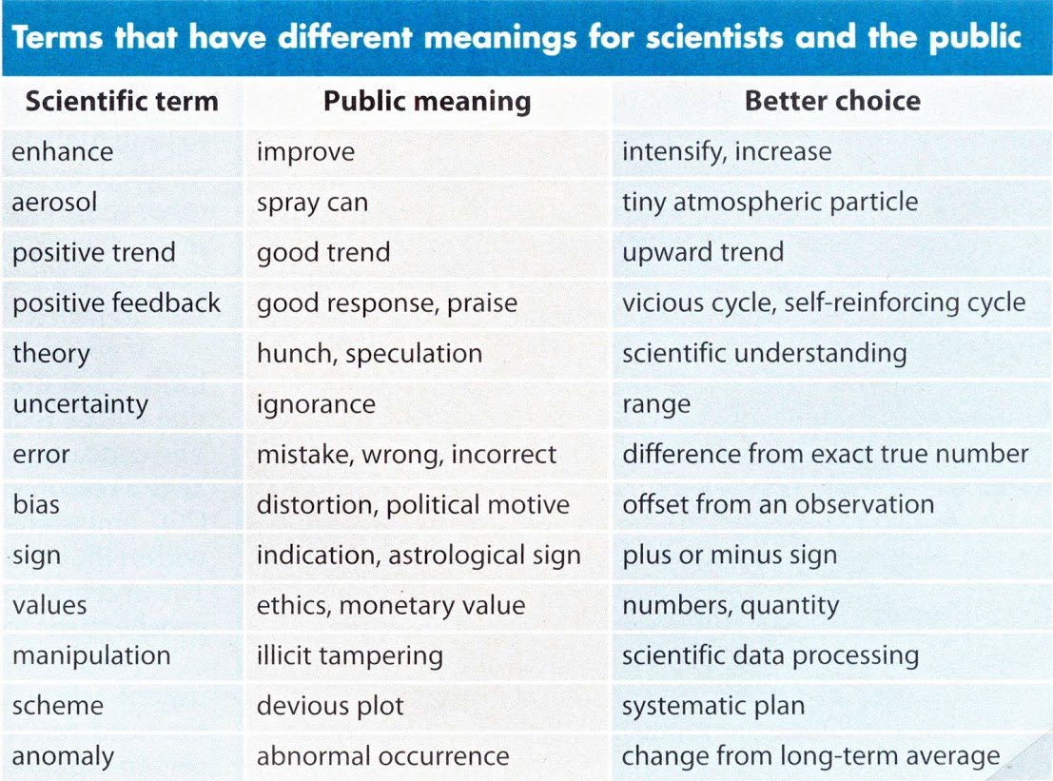
This Photo by Unknown Author is licensed under CC BY-NC

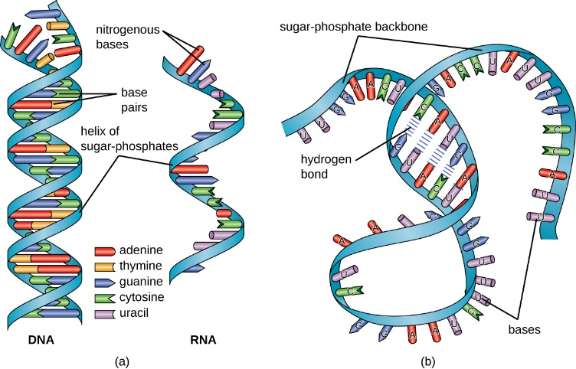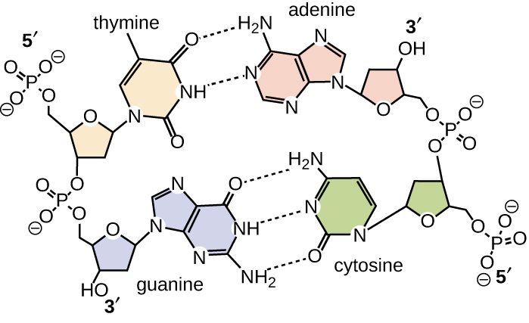
This Photo by Unknown Author is licensed underCC BY
This Photo by Unknown Author is licensed under CC BY

Glossary 
Term | Branch | Definition
Logic | Formal Sciences | Studies valid inference, argument structure, proof, syntax, semantics, fallacies, and sound reasoning.
Mathematics | Formal Sciences | Develops abstract structures and quantitative tools used across science.
Statistics | Formal Sciences | Collects, organizes, interprets, and evaluates data.
Systems Theory | Formal Sciences | Studies systems, feedback, self-regulation, and principles that apply across fields.
Decision Theory | Formal Sciences | Examines how choices are made and how optimal decisions can be evaluated.
Theoretical Computer Science | Formal Sciences | Uses mathematical rigor to study algorithms, computation, complexity, cryptography, and related areas.
Physics | Natural Sciences | Studies matter, motion, energy, force, spacetime, and the behavior of the universe.
Chemistry | Natural Sciences | Studies matter, substances, reactions, composition, structure, and properties.
Earth Science | Natural Sciences | Studies Earth systems including the atmosphere, hydrosphere, lithosphere, biosphere, and solid Earth.
Oceanography | Natural Sciences | Studies the ocean, marine ecosystems, currents, seafloor geology, and ocean chemistry.
Meteorology | Natural Sciences | Studies the atmosphere, weather, and forecasting.
Astronomy / Space Science | Natural Sciences | Studies outer space, celestial bodies, space exploration, and scientific work beyond Earth.
Biology | Natural Sciences | Studies life, organisms, cells, genes, evolution, and homeostasis.
Biochemistry | Natural Sciences | Studies chemical processes in and related to living organisms.
Microbiology | Natural Sciences | Studies microorganisms such as bacteria, viruses, fungi, protists, and parasites.
Botany | Natural Sciences | Studies plant life, including plant structure, growth, classification, and diversity.
Zoology | Natural Sciences | Studies animals, their structure, evolution, classification, behavior, and ecosystems.
Ecology | Natural Sciences | Studies interactions among organisms and their biophysical environments.
Social Research | Social Sciences | Uses multiple methods to study society, behavior, culture, and institutions.
Engineering | Applied Sciences | Applies scientific knowledge to design and build useful systems, structures, and technologies.
Medicine | Applied Sciences | Applies biological and scientific knowledge to health, diagnosis, treatment, and prevention.
Epidemiology | Applied Sciences | Applies biology and statistics to patterns, causes, and control of health conditions.
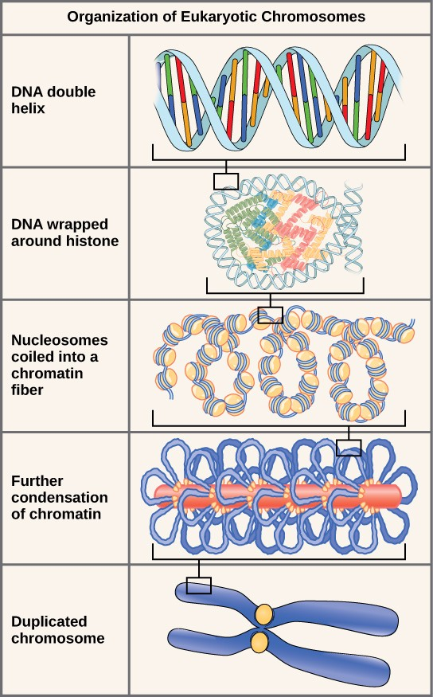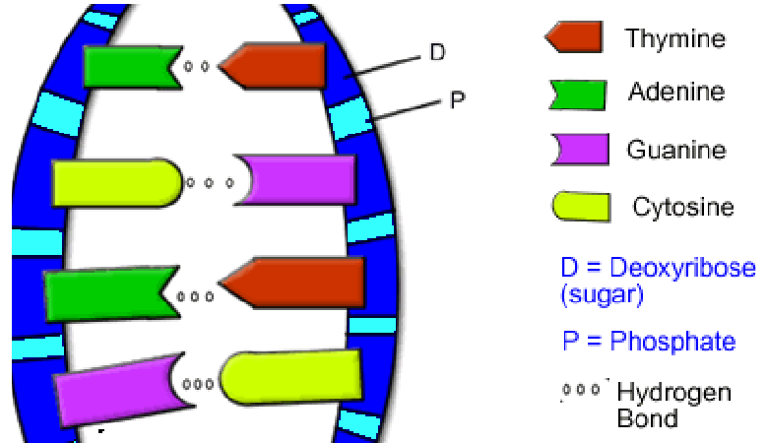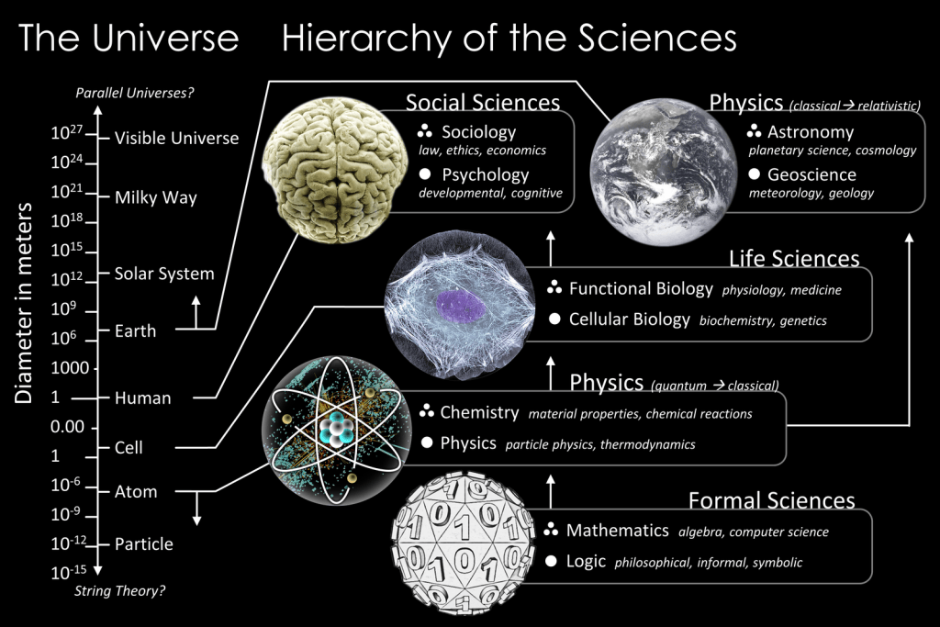
This Photo by Unknown Author is licensed under CC BY-SA
This Photo by Unknown Author is licensed under CC BY-SA-NC
