Bacterial Cellular Morphologies

Executive Summary
Bacterial morphology provides an early descriptive framework for interpreting microscopy findings and organizing introductory microbiology knowledge. Shape, arrangement, and curvature do not identify an organism by themselves, but they offer practical clues that help narrow classification, compare genera, and communicate observations clearly.

1. Major Morphological Categories
The most frequently discussed bacterial forms are cocci and bacilli, with additional attention given to curved, spiral, and helical cells. These categories are useful because they summarize visible structural patterns in a concise way and often align with characteristic modes of cell division or motility.
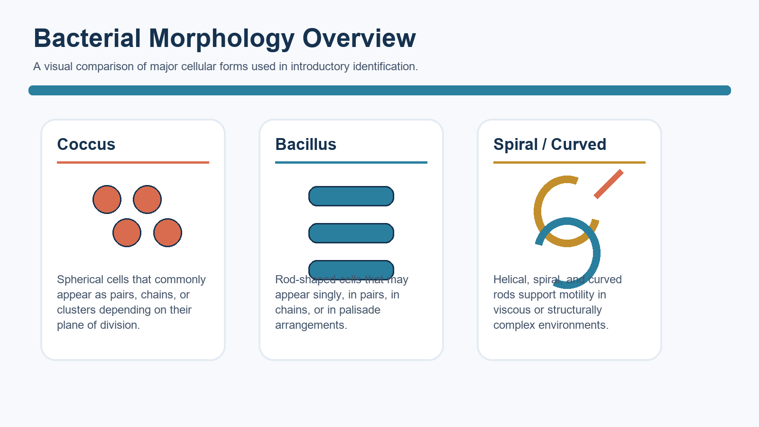
Figure 1. High-level comparison of coccus, bacillus, and spiral or curved morphologies.
Key: Coccus (spherical) Bacillus (rod-shaped) Spiral/curved forms (helical, spirillum-like, or vibrio-like)

2. Cocci
Cocci are spherical cells whose diagnostic description often depends on arrangement as much as on shape. After division, cocci may remain attached in pairs, chains, clusters, tetrads, or sarcina packets. Representative genera commonly introduced in this context include Staphylococcus, Streptococcus, Micrococcus, Enterococcus, and Neisseria.
These arrangements matter because they reflect planes of division and make microscopic observations more specific. For example, chain formation supports the description 'streptococcal,' whereas irregular clusters support the description 'staphylococcal.'

Figure 2. Common coccal arrangements used in laboratory descriptions and class notes.
Key: Diplococci (pairs) Streptococci (chains) Staphylococci (clusters) Tetrads (groups of four) Sarcina (packets/cubes)

3. Bacilli
Bacilli are rod-shaped cells that may appear singly, in pairs, in chains, or in side-by-side palisade patterns. In introductory microbiology, the term may refer to a shape, to the genus Bacillus, or to the class Bacilli, so context is important when the term is used.
Commonly cited examples of rod-shaped organisms include Escherichia coli, Salmonella, Listeria, Clostridium, and Corynebacterium. Short rods that approach a spherical appearance are often described as coccobacilli, as seen with organisms such as Haemophilus influenzae, Bordetella pertussis, and Yersinia pestis.

4. Spiral and Curved Forms
Spiral and curved bacteria include several structurally distinct forms. Spirilla are relatively rigid spirals, spirochetes are thin and flexible helices, and curved rods occupy a gentler arc that is often described as vibrio-like. Helical geometry can support movement through mucus or other viscous environments, making morphology relevant to both classification and adaptation.
Examples discussed in this category include Campylobacter, Helicobacter, Treponema, Borrelia, and Leptospira. Although these organisms differ substantially in physiology, their visible contours provide important descriptive shorthand during initial review.
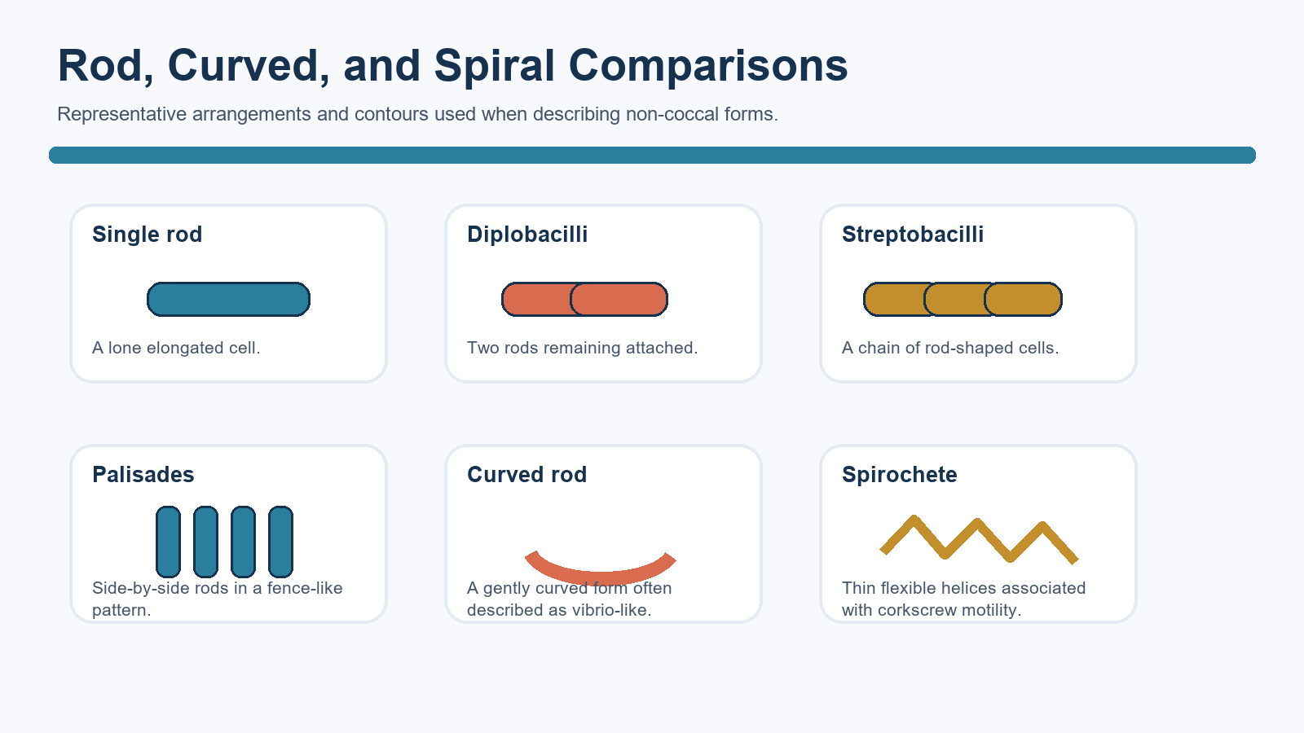
Figure 3. Selected rod, curved, and spiral patterns that appear in comparative morphology charts.
Key: Single rods (bacilli) Streptobacilli (rod chains) Palisades (side-by-side rods) Coccobacilli (short rods) Curved rods/vibrio-like (comma-shaped) Spirilla (rigid spirals) Spirochetes (thin flexible helices)

5. Labeled Bacteria Examples
The examples below can be used as a quick “label key” when studying morphology charts. (Reminder: shape alone is not definitive identification.)
Morphology label | Typical appearance | Quick examples (species)
Cocci | Spherical; often noted by arrangement (pairs, chains, clusters, tetrads, packets) | Staphylococcus aureus, Streptococcus pyogenes, Streptococcus pneumoniae, Neisseria meningitidis
Bacilli (rods) | Straight rod; may be single, chains (streptobacilli), or palisades | Escherichia coli, Salmonella enterica, Listeria monocytogenes, Corynebacterium diphtheriae
Coccobacilli | Short rods; intermediate between coccus and rod appearance | Haemophilus influenzae, Bordetella pertussis, Yersinia pestis, Francisella tularensis
Curved rods / vibrio-like | Comma-shaped or gently arched rods | Vibrio cholerae, Vibrio vulnificus, Campylobacter jejuni
Spiral / helical (non-spirochete) | Thicker helical/curved cells; “spirillum-like” (rigid spirals) are a classic example | Helicobacter pylori, Helicobacter hepaticus, Spirillum volutans
Spirochetes | Very thin, flexible helices; often not seen well without special microscopy | Treponema pallidum, Borrelia burgdorferi, Leptospira interrogans
Filamentous / branching | Thread-like filaments; may branch (actinomycete-like) | Actinomyces israelii, Nocardia asteroides, Streptomyces griseus
Pleomorphic | Variable shapes; may lack a typical rigid wall | Mycoplasma pneumoniae, Mycoplasma genitalium
- Cocci (spherical): Staphylococcus aureus (clusters), Streptococcus pyogenes (chains), Streptococcus pneumoniae (diplococci), Neisseria gonorrhoeae (diplococci), Neisseria meningitidis (diplococci), Enterococcus faecalis (pairs/short chains), Micrococcus luteus (tetrads), Sarcina ventriculi (packets)
- Bacilli (straight rods): Escherichia coli, Salmonella enterica, Bacillus subtilis, Bacillus anthracis, Clostridium botulinum, Clostridium tetani, Listeria monocytogenes, Corynebacterium diphtheriae (often palisades/“Chinese letters”)
- Coccobacilli (short rods): Haemophilus influenzae, Bordetella pertussis, Yersinia pestis, Acinetobacter baumannii, Brucella melitensis, Francisella tularensis
- Curved rods / vibrio-like: Vibrio cholerae, Vibrio vulnificus, Vibrio parahaemolyticus, Campylobacter jejuni
- Spiral / helical (non-spirochete): Helicobacter pylori (helical/curved), Helicobacter hepaticus, Spirillum volutans (rigid spirals)
- Spirochetes (thin, flexible helices): Treponema pallidum, Treponema denticola, Borrelia burgdorferi, Borrelia recurrentis, Leptospira interrogans
- Filamentous / branching: Actinomyces israelii, Nocardia asteroides, Streptomyces griseus
- Pleomorphic (variable shape; often lacks a typical rigid wall): Mycoplasma pneumoniae, Mycoplasma genitalium

6. Morphology and Adaptation
Cell shape is not only descriptive; it can also influence how organisms interact with their environment. Morphology is linked to surface area, movement, persistence in different niches, and, in some cases, pathogenic behavior. As one example, curved or helical forms may improve transit through structurally complex environments such as intestinal mucus.

7. Historical Context
Early bacterial classification relied heavily on visible form. Ferdinand Cohn is often credited as one of the first scientists to organize bacteria according to morphology, establishing a framework that remains useful in introductory teaching even though modern identification now depends on biochemical, molecular, and genomic methods.

8. Spreadsheet-Style Morphology Reference
The table below is formatted as a spreadsheet-ready reference so the same content can be transferred easily into
Primary form | Arrangement or subtype | Defining appearance | Representative examples | Interpretive value | Typical note
Coccus | Diplococci | Two attached spherical cells | Neisseria spp.; Streptococcus pneumoniae | Suggests paired post-division arrangement | Useful when describing pneumonia or meningitis isolates in class examples
Coccus | Streptococci | Chains of spherical cells | Streptococcus pyogenes | Indicates repeated division in one plane | Often linked to pharyngitis examples
Coccus | Staphylococci | Irregular grape-like clusters | Staphylococcus aureus | Supports clustered coccal description | Commonly cited in skin and wound infection discussions
Coccus | Tetrads | Groups of four cells | Micrococcus spp. | Helps distinguish less common coccal patterns | Seen in environmental and skin flora discussions
Coccus | Sarcina | Cube-like packets | Sarcina ventriculi | Memorable packet arrangement | Useful as a distinctive morphology example
Bacillus | Single rod | Elongated cylindrical cell | Escherichia coli | Baseline rod-shaped appearance | Common enteric morphology reference
Bacillus | Streptobacilli | Chains of rod-shaped cells | Streptobacillus-type arrangement | Shows continued attachment after division | Helpful for descriptive microscopy language
Bacillus | Palisades | Side-by-side fence-like rods | Corynebacterium spp. | Supports recognition of snapping division patterns | Frequently used in textbook diagrams
Coccobacillus | Short rod | Intermediate between coccus and bacillus | Haemophilus influenzae; Bordetella pertussis; Yersinia pestis | Explains why some rods resemble cocci | Important distinction during visual review
Curved / spiral | Curved rod | Comma-like or gently arched cell | Campylobacter; vibrio-like forms | Highlights departure from straight rods | Often associated with motility in fluids or mucus
Curved / spiral | Spirillum | Rigid spiral | Spirillum spp. | Identifies coarse spiral morphology | Useful contrast with spirochetes
Curved / spiral | Spirochete | Thin flexible helix | Treponema pallidum; Borrelia burgdorferi; Leptospira | Supports differential description of flexible spirals | Frequently referenced in systemic infection examples

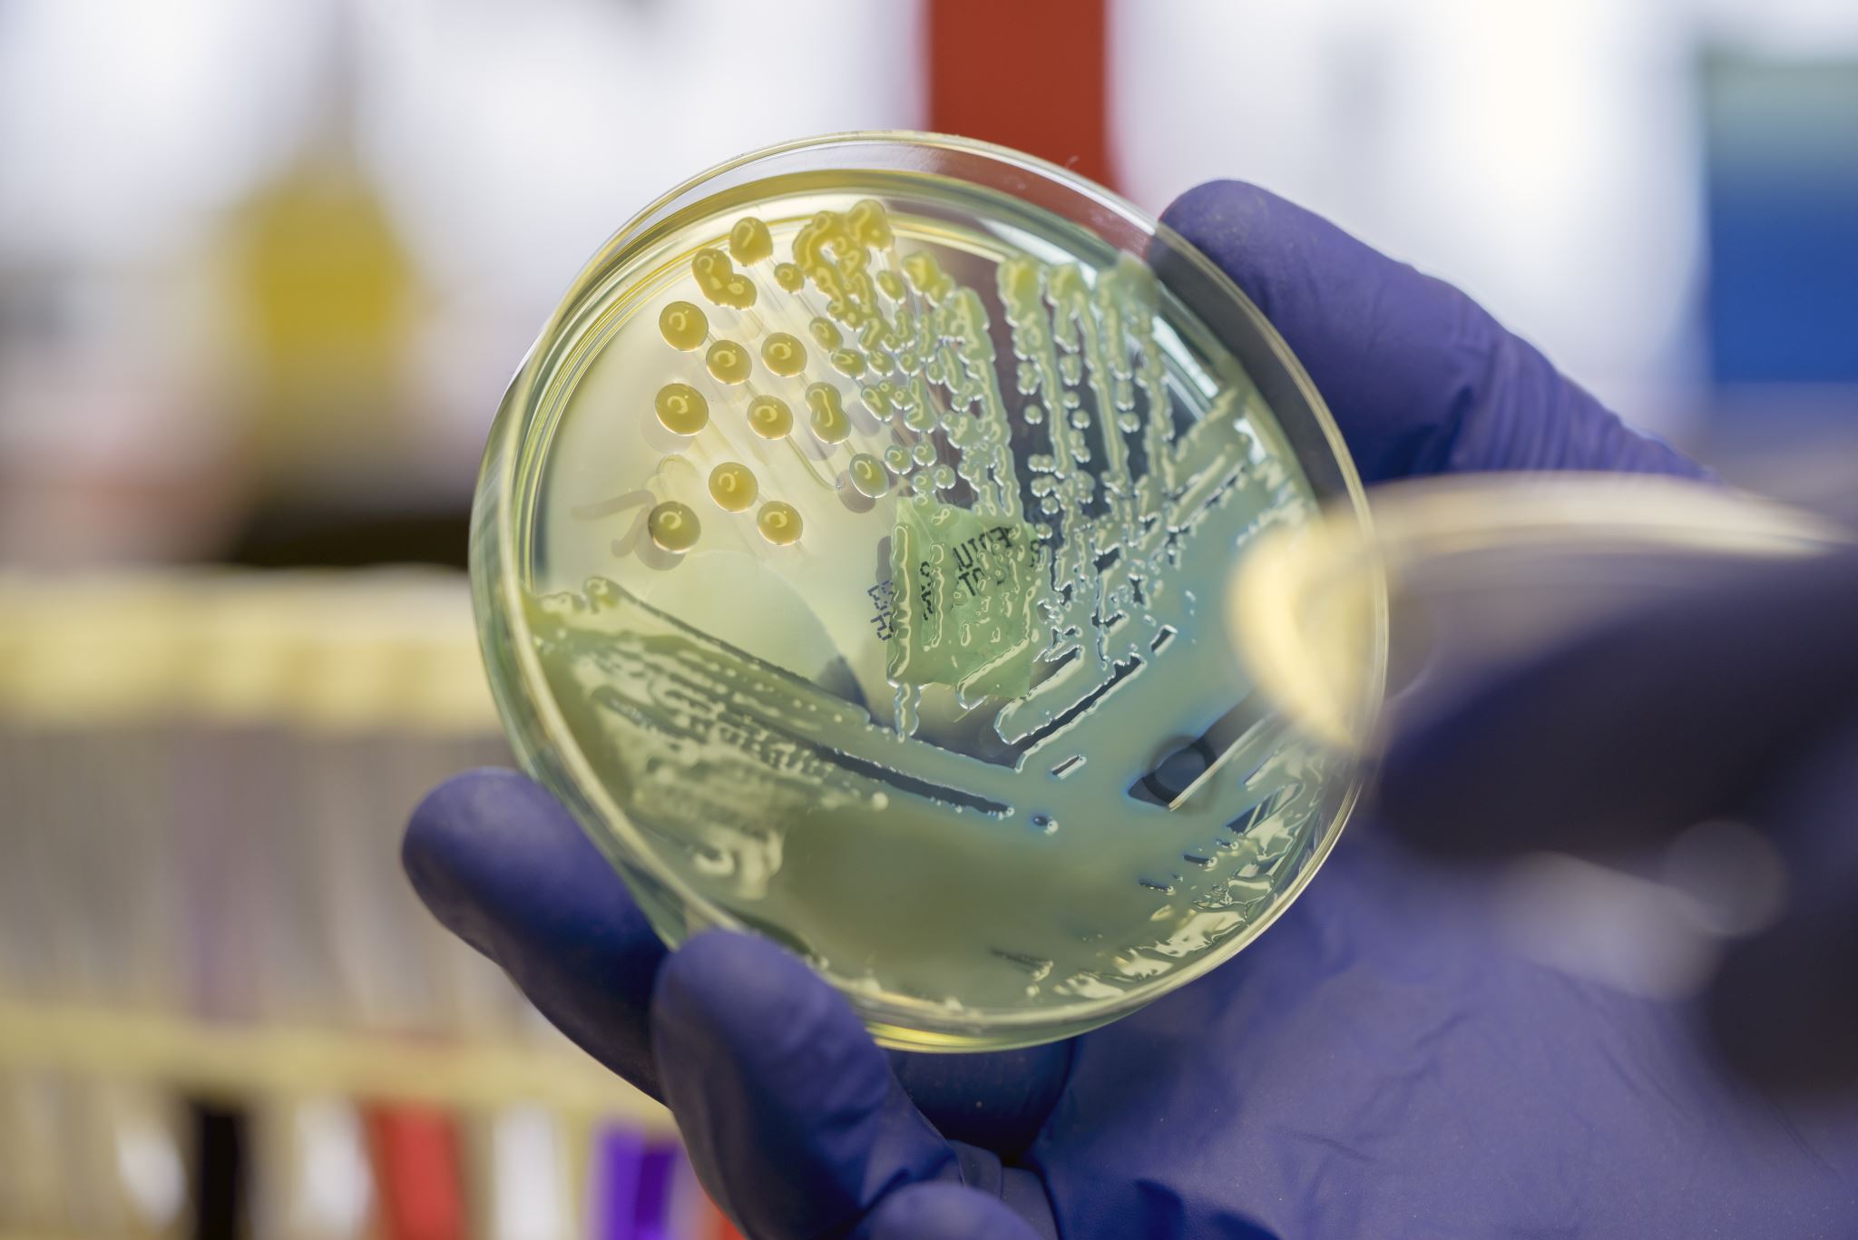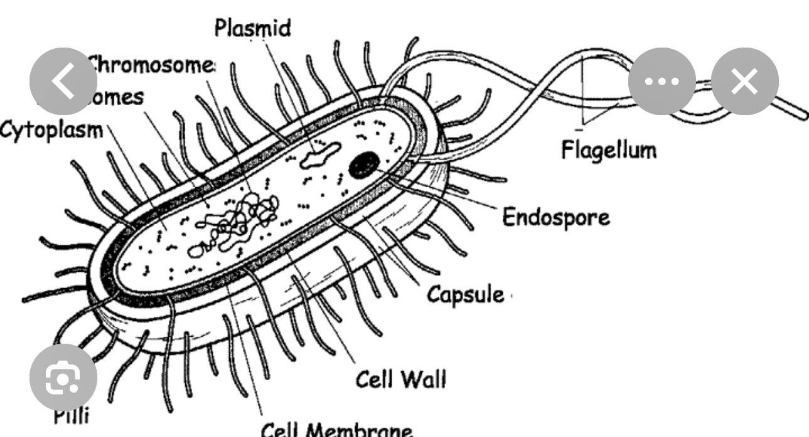
Bacteria Colony Bacteria Labeled
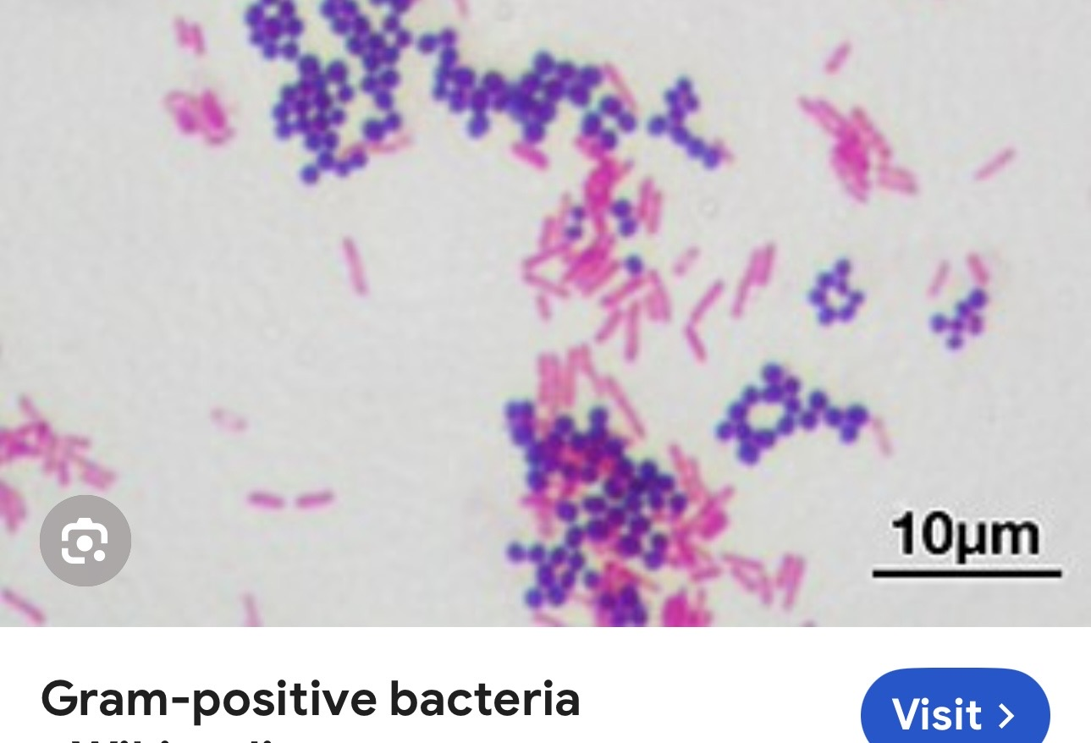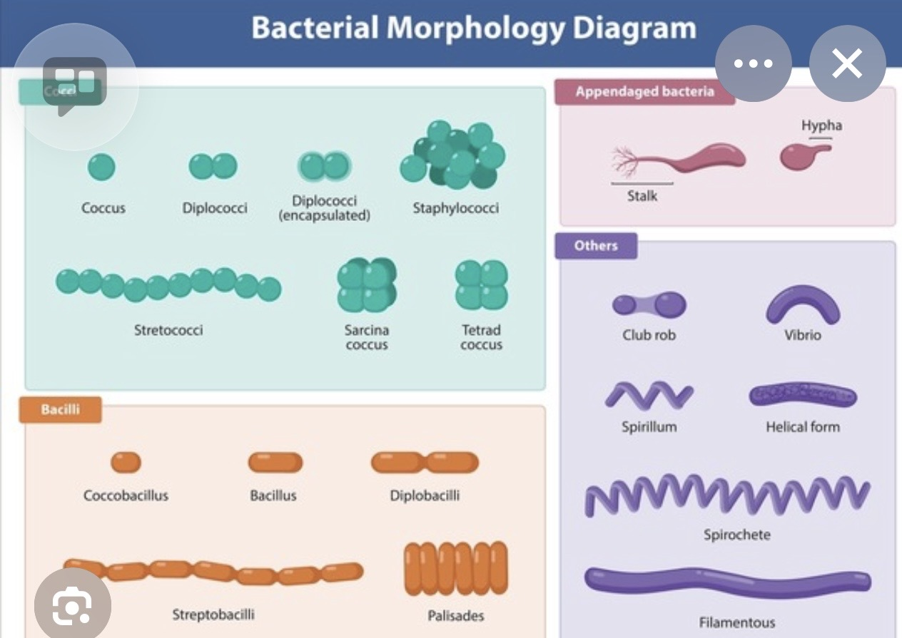
Bacteria; Microbiology:
Microbiology is much more likely to present us with hard ethics choices than, say, the cloning of human beings, which is something that would happen far out in the distant future, if ever

Gram-Positive Bacteria Bacteria Morphology Diagram

